**Hotel Cancellation Analysis**

**Business Problems**

The hospitality industry is highly dependent on booking revenue, and cancellations can cause significant losses for hotels. Therefore, it is essential to analyze hotel cancellation rates to understand the patterns and trends that can help hotels to minimize cancellations and increase their revenue. This projects aims to analyze hotel cancellation rates and provide recommendations for hotels to improve their booking policies.

Research Question

1. What are the variable that affect hotel reservation cancellations?
2. How can we make hotel reservation cancellations better?
3. How will hotels be assisted in making pricing and promotional decisions?

Hypothesis

1. More cancellation occurs when price is higher?
2. when there is no longer waiting list customers tend to cancel more frequently?

About the Data

To conduct this analysis, we will take the data from Keggle. The data will include the following 32 parameters and 119390 entries.

Analysis and Finding

The accompanying bar graph shows the percentage of reservation that are canceled and those that are not. It is obvious that there are still a significant number of reservation that have not been canceled. There are still 37% of clients who cancelled their reservation, which has a significant impact on the hotel’s earnings.

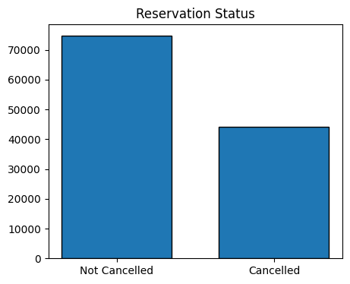

In comparison to resort hotels, city hotels have more bookings. It is possible that resort hotels are more expensive than those in cities.

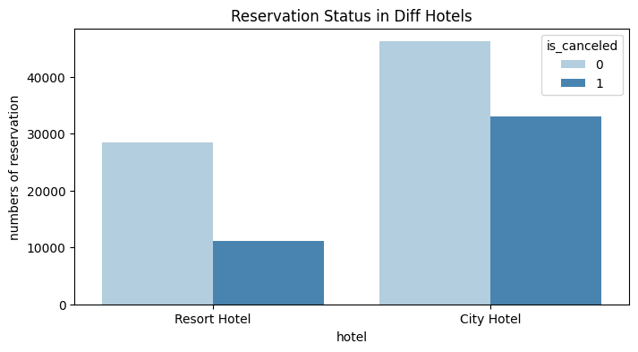

The line graph above shows that, on certain days, the average daily rate for a city hotel is less than that of a resort hotel, and on other days, it is even less. It goes without saying that weekends and holidays may see a rise in resort hotel rates.

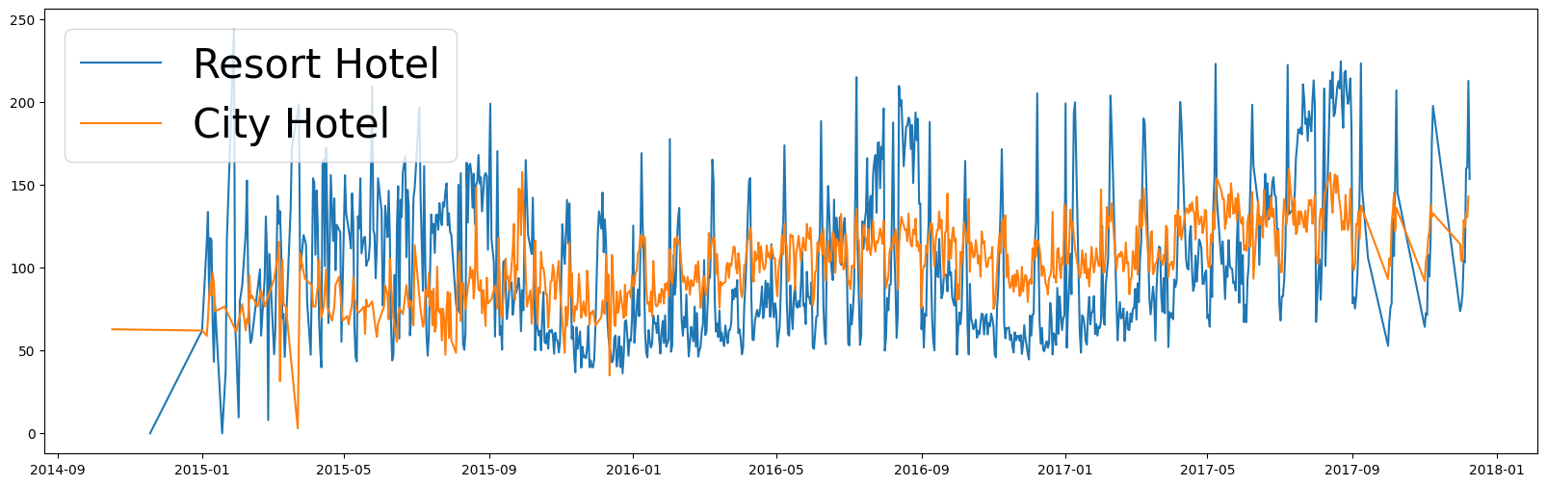

We have developed the grouped bar graph to analyze the months with the highest and lowest reservation levels according to reservation status. As can be seen, both the number of confirmed reservations and the number of canceled reservations are largest in the month of august. Whereas January is the month with most canceled reservations.

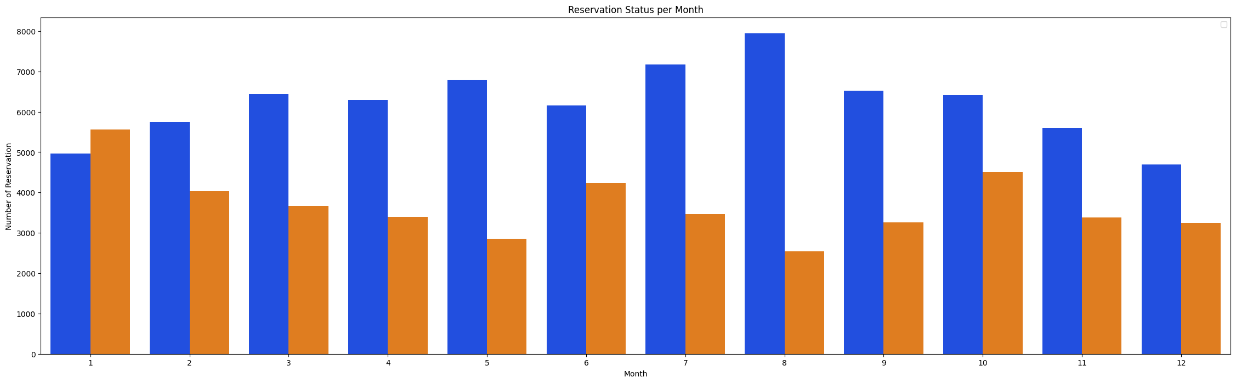

This bar graph demonstrates that cancellations are most common when prices are greatest and are least common when they are lowest. Therefore, the cost of the accommodation is solely responsible for the cancellation.

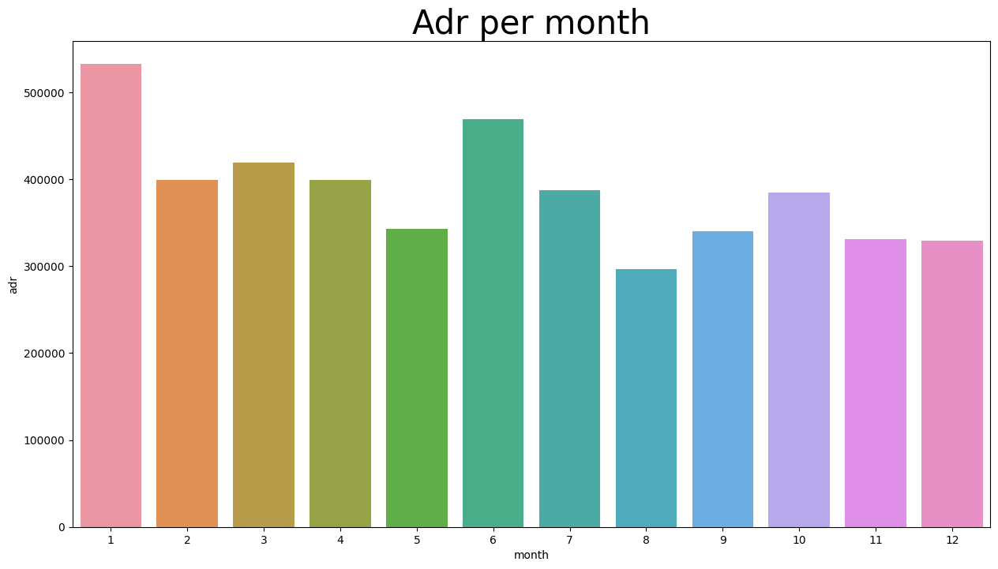

Now, let’s see which country has the highest reservation canceled. The top country is Portugal with the highest number of cancellations.

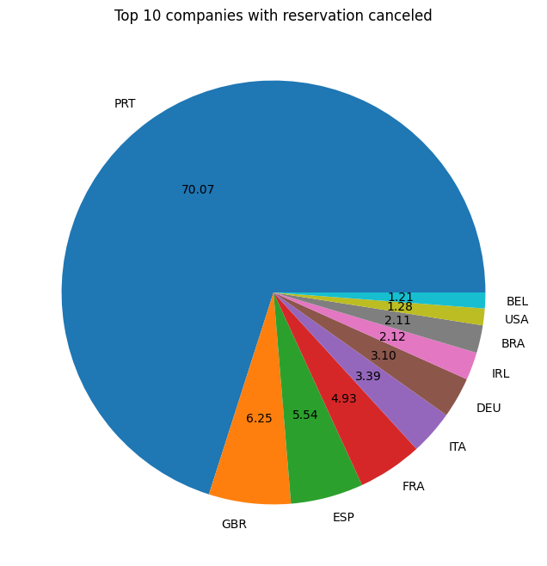

As seen in the graph, reservations are cancelled when the average daily rate is higher than when it is not cancelled. It clearly proves all the above analysis, that the higher price leads to higher cancellation.

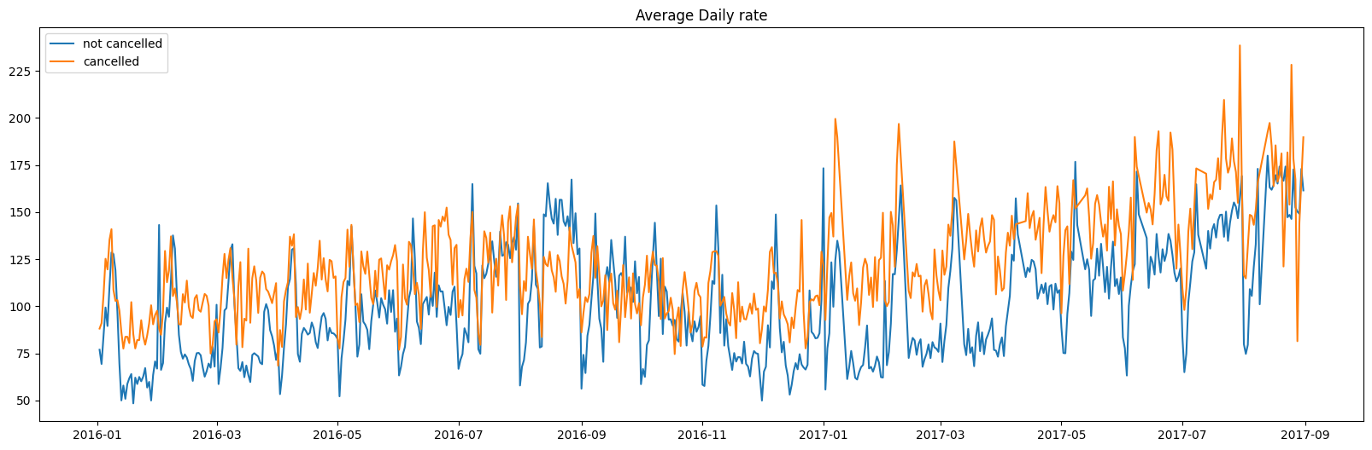

Suggestions

Cancellation rates rise as the price does. In order to prevent cancellations of reservations, hotels could work on their pricing strategies and try to lower the rates for specific hotels based on locations. They can also provide some discounts to the consumers.

As the ratio of the cancellation and not cancellation of the resort hotel is higher in the resort hotel than the city hotels. So the hotels should provide reasonable discount prices on room prices on weekend or on holidays.

In the month of January, hotels can start campaigns or marketing with a reasonable amount to increase their revenue as the cancellation is the highest in this month.

They can also increase the quality of their hotels and their services mainly in Portugal to reduce the cancellation rate.